42.16: For an average spacing a, the density is 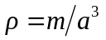, where m is the average of the ionic masses, and so
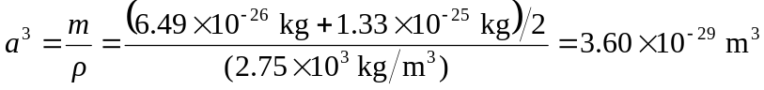,
and 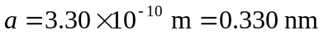. b) The larger (higher atomic number) atoms have the larger spacing.

